BERLIN .. NEON SESSIONS

When 7pm - 9pm, choose 2nd or 3rd of October 2026
What A two hour neon session on what neon is, what it can be and how to make it. See glowing examples of neon art explained, expect mesmerising demos with glass, flame and electricity, have a go yourself and take home the results.
Cost £160 / €180
Where Berlin Flameworking Studio, Rollbergstraße 28A, 12053 Berlin, Germany

+49 1516 2644423 info@berlinflameworkingstudio.com
Bring Just yourself, we provide the glass, fire, gas, electric and excitement!
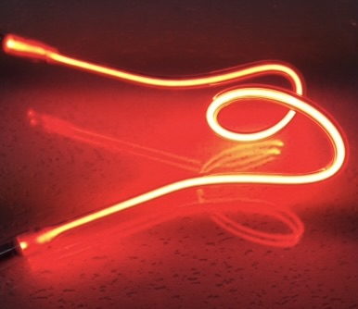
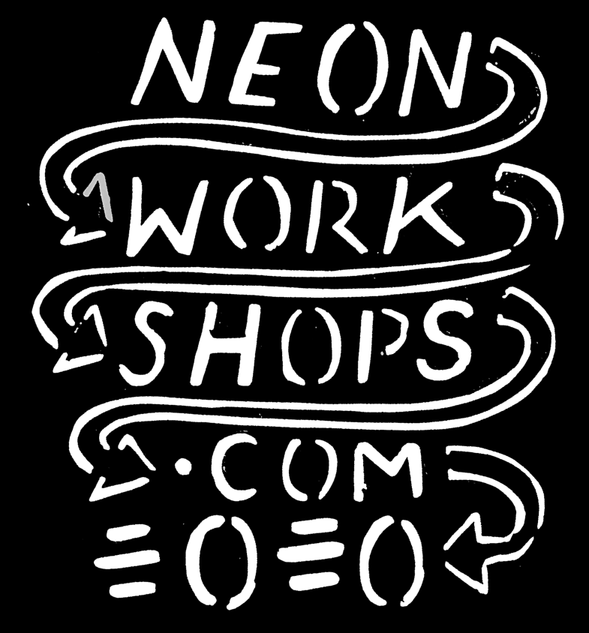
Price includes power supply and turning your glass attempt into neon.
Photo below of neon squiggle is typical example of what you will leave with.
If your neon isn’t ready on the evening, you can collect from the studio from the next morning onwards

