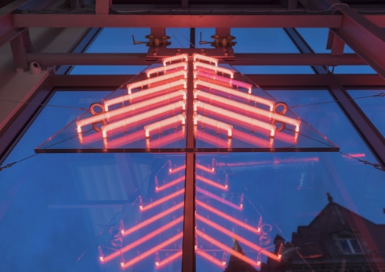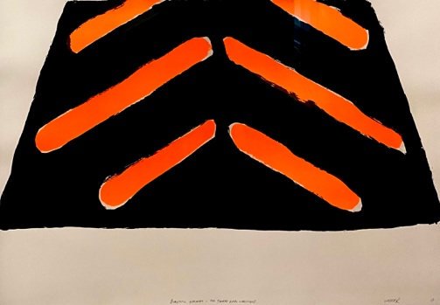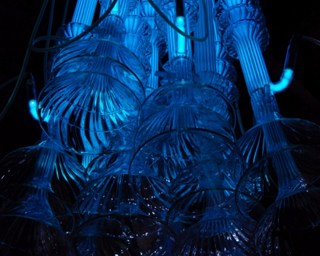

The Neon Chandelier - Richard Wheater - Berlin
A three day Masterclass
2nd, 3rd, 4th October 2026
Or
9th, 10th, 11th October 2026

Cost: €975/£850 (includes all materials and power supply, excludes food & accommodation)
Lead tutor Richard Wheater + facilitators from the Neon Workshops team
Maximum 8 participants

Summary:

You will be based at the heart of one of Europe’s most creative capitals, in Berlin Flameworking Studio and taught by artist Richard Wheater, founder of renowned British neon powerhouse; Neon Workshops. The class will use borosilicate tube and special hot torches with oxygen, to use this hard glass with heaps of sculptural potential. You will design and make a piece of illuminated gas-filled glass, suspended indoors or outdoors. Once individually documented, the group will work together with the tutors to assemble one stunning hanging light chandelier, using everyone’s neon components. You will leave at the end of the three days with your handmade neon, power supply and hanging fixings.
No experience is necessary.

Methods:

. Developing paper bending templates and maquettes, whilst introduced to a library of neon resource
material.
. Working with borosilicate glass, various colours and diameters, using three different flame hot
torches, dedicated for borosilicate hard glass.
. Processing using an Electron Bombarder - and oven pump system
. Experimenting with different gas pressures, single electrode neons and crackle tubes
. Introduction to different power supplies and safe wiring methods
. Bespoke installing/suspending techniques

Things to bring with you
. Non-flammable clothing, jeans and cotton are ideal
. Safe footwear, no open toed sandals/flip-flops
. Camera and/or documenting method.

Venue:
Berlin Flameworking Studio
Rollbergstraße 28A,
12053 Berlin,
Germany
info@berlinflameworkingstudio.com

Contact:
For any questions, please contact Neon Workshops:
info@neonworkshops.com
+44 1924 200 069

Schedule:

Day 1

Morning (10am)
- Introduction to neon making through anecdotes and props
- Discuss location, possible areas of inspiration and how glass/neon can relate
- Tutor glass demonstration - joining glass/electrodes, using different diameters
- Hand drawing ideas to template stage, and making maquettes
(also demonstrating examples using Adobe software)

Afternoon (1:30pm)
- Tutor glass demonstration - Electron Bombarder & Oven pump processing
- Discuss and confirm students ideas
- Students start working with the hot torches, making their ideas
- Tutor glass demonstration - Blocking out & wiring power supplies
- Clean up for 5pm finish

Day 2

Morning (10am)
- Tutor glass demonstration - Installing/hanging methods
- Students continue with making their ideas towards completion
- Completed glass sections, electroded and processed with gas

Afternoon (1:30pm)
- Tutor glass demonstration
- Students finish their glass work
- Clean up for 5pm finish

Day 3

Morning (10am)
- Tutor glass demonstration - Installing/hanging methods
- Students hang/install their neons with tutor support
- Hung neons documented with tutor support

Afternoon (1:30pm)
- All neons brought together and hung from the studio ceiling as one neon chandelier
- Everyone’s work carefully packed
- End of workshop de-brief
- Clean up for 5pm finish

